Geometric Brownian Motion and Stock Prices

FINAL-PROJECT REPORT

AM 3611

FALL 2018

ZHEYUAN JIANG (250849859)

YIZHOU TANG (250888541)

SHICHEN LIN (250882036)

1. **Introduction**

A growing trend in personal and corporate investments has been prevailing for a number of years. A stock is an indispensable source to making a profit for investors in this economy dominated society[1]. However, as there is an increasing number of people entering the stock’s world so that the market becomes fierce competition. It is extremely challenging to benefit from the huge swings of stock prices. Only the person who has an ability to acquire more relative information and more professional knowledge of data analysis in advance could forecast the tendency of stock prices more precisely and win from the surge of the stock market. So, what are the most essential models for predicting stock values? And how to apply those algorithmic models to the actual stock market?

Geometric Brownian Motion (GBM) is a simple algorithm to model future stock price actions. Although GBM is not a perfect model to precisely predict the exact future prices, it could efficiently help investors to see the possible rise and fall of a stock and understand the potential risk in one’s portfolio. GBM is a convenient model for stock price modeling because it satisfies the three general assumptions of the stock market:

1. The expected returns from the Geometric Brownian Motion process are independent of the value of the stock price, which keeps correspondence with what we would expect in reality.

2. A GBM process only predicts positive values, just like real stock prices which would not arise any negative number.

3. A GBM process shows the similar 'roughness' in its paths as the actual path of stock prices.

Further, people are willing to use derivatives, the financial instruments whose price depends on the performance of some underlying asset or assets, to hedge the risk of stocks. Options are a particular type of derivatives which are usually used in the stock market. An option is a contract which gives the buyer or the owner the right, but not the obligation, to buy or sell an underlying asset or instrument at a specified strike price prior to or on an expired date. There are different types of options, including American option, European option, Bermudan option and so on. European option which is an option that may only be exercised on expiry is common in modern stock options. A model called Black and Scholes creates a closed-form solution for a theoretical price of European call option and put option[8]. The Black–Scholes model assumes that:

1. The risk-free interest rate is constant;
2. The instantaneous log return of stock price is an infinitesimal random walk with drift;
3. The stock does not pay a dividend;
4. There is no arbitrage opportunity;
5. It is able to borrow and lend any amount of cash under the riskless rate;
6. It is able to buy and sell any amount of the stock;
7. The above transactions do not incur any fees or costs.[9]

If the present stock market satisfied with such assumptions, Black and Scholes formula could help investors to make assumptions for the options price and help them to analysis whether should they do the investments or not.

1. **Conceptual Framework of the Problem**

For predicting the price by GBM, there is the closed-form solution of GBM and a simulation way, which are not a perfect solution. The goal for the mini-program is to find a way to reduce the results’ errors of predicted price by numerical model. One solution is to find the effect of results using the different step size. If the difference between the results from operating the simulation method and GBM is subtler, the more confidence with the predicted stock price acquired by a computational algorithm. The expected conclusion after comparing the different assumption is that smaller step size chosen to be used in the formula, the smaller error would occur.

After predicting the stock price and finding the error, we would use Black and Scholes formula with the stock price at least error calculated to compute an option price of SPY in a specific day. Next step, adding all of the possible discounted payoffs of (St-K)+, where St is the spot price at time t and K is strike price set in option, by using normally discounted formula is expected to compare with the option price under Black and Scholes calculation. What we expect is two computed prices of one option in different methods would be close. If the discounted price has a huge difference with the option price of Black and Scholes, we would further study what the factor induces such difference. In order to better understand the affecting factors of the result of operating Black and Scholes, the program will break down and analyzes each Greek in the Black and Scholes formula. To understand the what does each Greek measure and how to compute them is a perfect way to study the Greeks. Also, plotting the curves which expect to show the changes as the numerical changes of each Greek could not be ignored.

**C. Numerical model/computational algorithm to be used to solve the problem**

A Geometric Brownian Motion is a typical model with a continuous-time stochastic process[3], which is satisfied with the stochastic differential equation: dS=μS dt+σS dWt, where S is the stock price and we note that St is the stock price at time t, μ is the mean of previously chosen stock prices, also called drift coefficient, and σ is percentage volatility called diffusion coefficient. Both μ and σ are constants as St changing[4], but we would add extensions to approximate a changing μ and σ when the time t is changing in the full project. Wt in the stochastic differential equation is a Brownian motion, called Wiener process as well. Brownian Motion is usually used to express the movement of time series variables, and the corporation of the financial movement of stock prices[5].

Each Brownian increment Wi is calculated through multiplying a standard random variable zi from a normal distribution N(0,1) with mean 0 and standard deviation equal to 1 by the square root of the change of time √∆ti, in order that Wi= zi*√∆ti. The graph Brownian increment would look like figure 1.

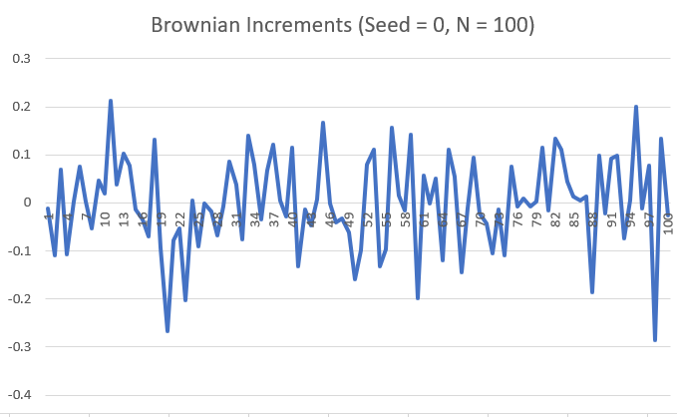

Figure 1.

The Brownian Motion Wt is the cumulative sum of the Brownian increments Wi, noted as Wn(t)=∑Wi(t), which explains the random portion of the equation[6].Therefore, a wave curve of Brownian Motion could be obtained as the Figure 2 below. Then, according to the stochastic differential equation above with an initial condition from the stock price path S(0)=S0, an analytical example closed-form solution of GBM equation dS=μS dt+σS dWt would be

S(t)=S0*exp((μ-(1/2)σ^2)*t+ σWt),

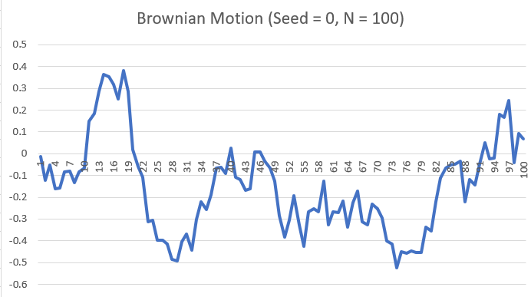

Figure 2

But if there is no any close-form solution for GBM, a technique to approximate the solution for stochastic differential equation is the Euler-Maruyama Method. Euler-Maruyama’s equation is

w[i+1] = w[i]+μ*w[i]Δt[i]+σw[i]ΔW[i]. [7]

The project would use both the solution of GBM and the Euler-Maruyama approximate to simulate different price paths. We will compare the results from two methods and find the errors of the approximate technique.

Through coding the program, the future stock price could be simultaneously calculated by using both Geometric Brownian Motion Model and Euler-Maruyama Method. The average difference between results from the Euler-Maruyama approximate and GBM from different seeds would also be presented. It is easy to comprehend that if fewer errors exist, the more accurate the numbers program have predicted.

The whole program includes three files, the header file stock.h, the main file stock.cpp and SPY.txt which contains the historical adjusted close data of SPY collected from Yahoo! Finance (2017-11-21 to 2018-11-20). The class Stock is in the header file with drift coefficient, diffusion coefficient, time period, price delta and other variables used in GBM model calculating and Euler-Maruyama approximating. In the main file, reading the SPY data from SPY.txt as an array to the program, initializing and valuing the variables including price delta, mu and sigma is the first part. Then, code builds the Brownian Motion Model from the random normal distribution libraries to compute the Wn(t)=∑Wi(t) shown as W[i] in the code. By applying the Brownian Motion W[i] from the last step, the predicted stock price could be assumed by GMB in the third part of the code. At the same time, calculation of the simulated price by using Euler Maruyama Approximation would process in part four. The fifth step is the find the simulated value of the stock by linear solution and prints out the prices at the corresponding time. Finally, return to the results from Geometric Brownian Motion and Euler Maruyama approximation and compare the average differences between results under difference chosen step size. Plotting the graph by outputted data through excel to check if the outcome is the same as the first expectation.

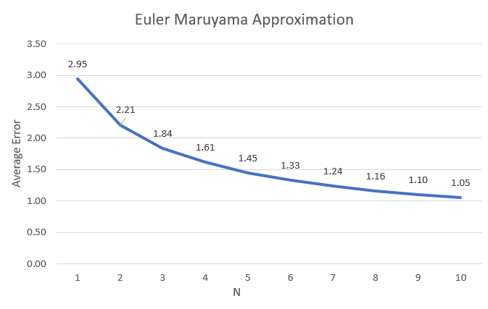  
Figure 3

The processes and code above are included in the mini project. It is easy to conclude that the bigger time size (the smaller step size) in GBM model, we would have the stock price with less difference between Euler-Maruyama approximation and closed form GBM solution. After concluding from the mini project, the next step is to choose a stock price St from GBM with less error, which uses a large time size number such as 1000, and to calculate an option price by Black-Scholes Model.

For moving to the Black-Scholes Model and option price, the inheritance of class Stock symbolizes a beginning new module of computing options. The Black–Scholes equation is a partial differential equation to process the price of the option over time. The equation is shown below:

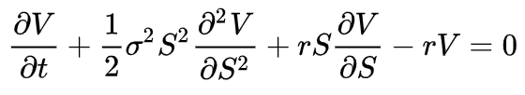

The notation S is the price of the underlying asset at time t, which is the result from GBM calculation. V(S,t) represents the price of the option as a function of the spot price S at time t, and r is the annualized risk-free interest rate, continuously compounded also known as the force of interest. σ and μ would be inherited from the GBM formula. Through solving the equation, the Black–Scholes formula draws out the call option as follows:

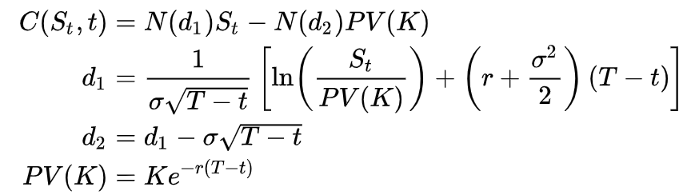

And also the put option through the put-call parity:

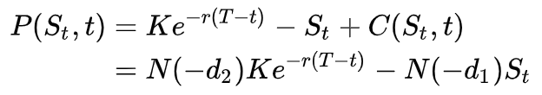

C(S,t) represents the price of a European call option, and P(S,t) denotes the price of a European put option. N(x) is a [standard normal](https://en.wikipedia.org/wiki/Standard_normal) cumulative distribution function with N’(x) which is the standard normal probability density function for N(x), By operating the program we could obtain the prices of a call option and a put option. We first return N’(x) by coding the formula:

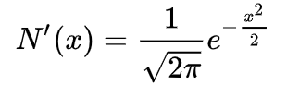

and also the N(x) by the formula:

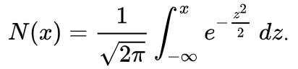

with d1 and d2 which formulas show above with the call option price.

After writing the codes for calculations of all elements in the call option formula, the code for Black–Scholes formula could be completed with d1, d2 and N(x). Because the price of put option is able to easily acquire by the put-call parity formula, we do not have the plan to add specific code to study the put option.

In order to have a better insight of option price, we would like to obtain another call option price by discounting all of the possible payoffs (St-K)+ and adding the result from multiplying each payoff by its corresponding probability made use of ‘for loop’. The same process will also fit in pull option price calculation. Because the St derives from a normal distribution, it is possible to compute the probability of each payoff by z-score. Now, it is obvious that two sets of options price are close by comparing the options by different algorithms. As the expectation, the options stem from Black–Scholes model is quite accurate in the aspect of the scientific algorithm. However, the Black–Scholes model has limitations with market assumptions, and the theorem relies on a number of assumptions that do not necessarily adjust well to reality.

Further research for the Black–Scholes model, analyzing the Greeks is indispensable. "The Greeks" measure the sensitivity of the value of Black–Scholes model to changes in parameter values while holding the other parameters fixed.  The Greeks for Black–Scholes are obtained by differentiation of the Black–Scholes formula in closed form. The solution for each Greek in call option and pull option are shown in the form below[10]:

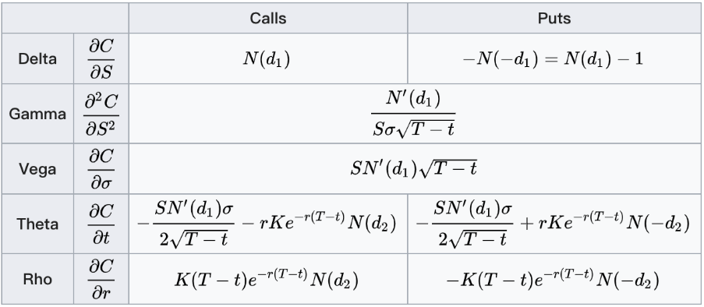

Delta is the most important Greek because it typical confers the largest risk. There is an interesting relationship with put and call option with delta. Given a European call and put option with no dividend yield for the same underlying, strike price and time to maturity, due to put-call parity, the delta of the call (positive) minus the delta of the put (negative) equals 1. Many investors will initialize their delta to zero at the end of the day if they are speculating and following a delta-neutral hedging approach as defined by Black–Scholes. Gamma, a second order Greek, measures the rate of change in the delta with respect to changes in the underlying price. For Vega, the derivative of the option price with respect to the [volatility](https://en.wikipedia.org/wiki/Volatility_(finance)) of the underlying asset measures sensitivity to [volatility](https://en.wikipedia.org/wiki/Volatility_(finance)). Theta is a time relative Greek, which measures the sensitivity of the value of the derivative to the change of time. Rho represents the sensitivity of the interest rate, which is the derivative of the option value with respect to the risk-free interest rate.In our program, we would study all of Greeks in the form and code the function as the form shows. In the program, each Greek would be a variable calculated according to the above formula under call options, and it will print the all of the results for five Greeks[11].

For the final step for our all project, the gnuplot for the Greeks is coded in the program to illustrate the influence of fluctuation as the Creeks change.

**D. Results**

Above are the results of the Euler Maruyama Approximation. As the graph clearly suggests, as the number of steps(N) increases (which means step sizes decreases), the average error decreases as well. From the chart above, we were able to confirm the relationship between Euler Maruyama Methods ’s accuracy and the number of steps.

Below is another chart showing different sample paths generated in our program:

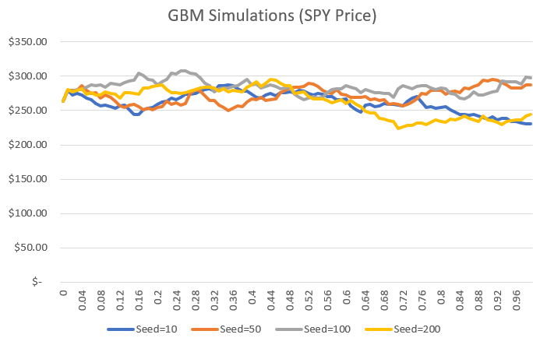

Figure 4

According to the result above, we chose a small step size to operate the GMB program and use the outcome St with less error to compute a call option price with the Black–Scholes Model. Also, we obtain another call option price by a specially discounted method. By means of the comparison with two call options prices, we found that the two prices are close as expected. In next process, five Greeks are successfully computed and printed out.

The result of our code and the graphs about two important Greeks are shown below:

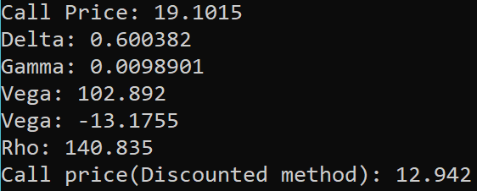

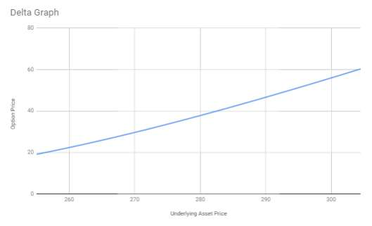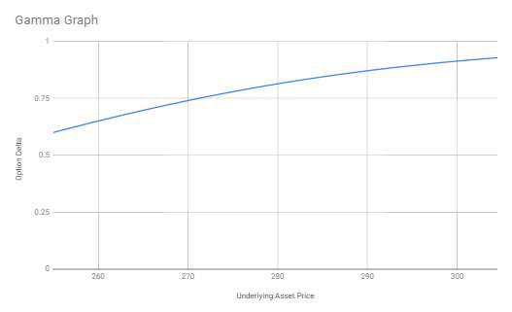

**E. Conclusion**

From the figure 4 above, it shows several paths, they all start from the same spot which is the stock price at time zero, but these paths with different seeds are totally different and random. Therefore, if there is vitality in a stock, which is certainly in the real world, the future tendency of a stock is unpredictable and random, and it is uncertain that a stock might achieve at a certain price or level in the future.

Nevertheless, we still have the incentive to simulate these possible paths that can be an essential benchmark to make a financial decision. In the figure 3, it reveals the relationship between the step size of the Geometric Brownian Motion Model and Euler-Maruyama Method and the average error defined by the absolute value of the difference of each simulated last-day stock price between Geometric Brownian Motion model and Euler-Maruyama Method. The relationship is obvious that when the step size decreases, the average error decreases. The step size here represents the number of increments, which graphically represents each fluctuation of the stock price. The average error here represents the accuracy that the Euler-Maruyama method can provide, hence the conclusion can be comprehended as that when the step size becomes smaller, the accuracy of the Euler-Maruyama method increases. In addition, the reason that the step size starts from 1 is that it is the biggest value that a step size can be, which can easily reveal the relationship to the average error.

In the processes of operating Black–Scholes Model to find out the call option price, all elements d1, d2 and N(x) are returns successfully so that the complex Black–Scholes formula could run and output a call option price. Comparing with the option price with discount formula, the numbers are very different. Therefore, our discounted method is not perfect as Black-Scholes since the difference is almost 50%. However, it is still important to notice that the Black–Scholes formula is not perfect, it has a lot of restriction that the real market is hardly satisfied simultaneously. As the change of the Greeks in Black–Scholes model will affect the outcomes and fluctuations of the numerical outcome of options.

In addition, we can see from the graph of output delta and gamma, where the x-axis of them are all different stock price, and the y-axis are option prices and delta of the option respectively. The slopes of each point in these two graphs are corresponding to its Greeks, delta and gamma respectively because of the definition of these two important Greeks. And we can conclude that the European call option price and its delta increase with the increase of the stock price. And it seems like the gamma of this option is decreasing with the increase of the stock price in this interval.

For the further research, topic can focus on how to calculate the predicted price of an American call option which is the most popular options with specific strike price through other complicated mathematical models. For computing theoretical American option price, we have to study a concern about rate changing for every future day.

Additionally, it worthwhile to study the local volatility model that can improve the existing Geometric Brownian Model, which use a constant volatility while the volatility is always fluctuating in the real world.

1.https://www.streetdirectory.com/travel_guide/36650/investment/the_importance_of_stock_research_and_analysis.html

2. Hull, John (2009). "12.3". Options, Futures, and other Derivatives (7 ed.).

3. Ross, Sheldon M. (2014). ["Variations on Brownian Motion"](https://books.google.com/books?id=A3YpAgAAQBAJ&pg=PA612). Introduction to Probability Models (11th ed.). Amsterdam: Elsevier. pp. 612–14. [ISBN](https://en.wikipedia.org/wiki/International_Standard_Book_Number) [978-0-12-407948-9](https://en.wikipedia.org/wiki/Special:BookSources/978-0-12-407948-9).

4. <http://www.columbia.edu/~ks20/FE-Notes/4700-07-Notes-GBM.pdf>

5. https://ro.uow.edu.au/cgi/viewcontent.cgi?article=1705&context=aabfj

6.  Durrett 1996, Sect. 7.1

7. Kloeden, P.E. & Platen, E. (1992). Numerical Solution of Stochastic Differential Equations. Springer, Berlin. [ISBN](https://en.wikipedia.org/wiki/International_Standard_Book_Number) [3-540-54062-8](https://en.wikipedia.org/wiki/Special:BookSources/3-540-54062-8).

8.Black, Fischer and Myron S. Scholes. "The Pricing of Options and Corporate Liabilities", Journal of Political Economy, 81 (3), 637–654 (1973).

9.Black, Fischer; Scholes, Myron. "The Pricing of Options and Corporate Liabilities". Journal of Political Economy. 81 (3): 637–654. doi:10.1086/260062.

10.Although with significant algebra; see, for example, Hong-Yi Chen, Cheng-Few Lee and Weikang Shih (2010). Derivations and Applications of Greek Letters: Review and Integration, Handbook of Quantitative Finance and Risk Management, III:491–503.

11. Haug, Espen Gaardner (2007). *The Complete Guide to Option Pricing Formulas*. McGraw-Hill Professional. ISBN 9780071389976. ISBN 0-07-138997-0